Final Project Report Machine Learning-Based
Rehabilitation Motion Classification
This project investigates the application of machine learning techniques for the classification and evaluation of rehabilitation motion data. The objective is to design an automated and objective method for identifying different rehabilitation exercise patterns using time-series trajectory data. We propose a deep learning framework based on Long Short-Term Memory (LSTM) networks combined with an attention mechanism. Experimental results demonstrate that the proposed model effectively captures temporal dependencies and achieves reliable classification performance.

- Introduction

Rehabilitation therapy plays a crucial role in patient recovery. Traditional assessment methods rely heavily on subjective evaluation by therapists. With the increasing availability of motion capture data, machine learning provides an opportunity to perform objective and automated analysis. This project aims to develop a classification system for rehabilitation motions using deep learning techniques.

- Related Work

Previous research has applied traditional machine learning methods such as SVM and k-NN to motion classification tasks. However, these methods require handcrafted features and are limited in modeling temporal relationships. Recent studies show that LSTM and attention-based models outperform traditional approaches in time-series motion analysis.
In recent years, deep learning techniques have become increasingly popular in the field of rehabilitation motion analysis. Convolutional Neural Networks (CNNs) have been applied to spatial feature extraction, while Recurrent Neural Networks (RNNs) have demonstrated effectiveness in modeling temporal dependencies. Among RNN-based models, Long Short-Term Memory (LSTM) networks are particularly suitable for rehabilitation data due to their ability to mitigate the vanishing gradient problem.
Furthermore, attention mechanisms have been introduced to improve model interpretability and performance. By assigning higher weights to informative time steps, attention-based models allow researchers to analyze which motion segments contribute most significantly to classification decisions. This characteristic is especially valuable in rehabilitation scenarios, where understanding patient movement quality is as important as achieving high classification accuracy.

- Team Roles and Project Organization

This project was conducted by the bubble team. WANG YUMING managed project scheduling and coordination. 우시시 handled data loading, preprocessing, and visualization. 이멍멍implemented the model training pipeline and optimized parameters. 유열prepared the final report and mentor documentation.

- Data Description

The dataset consists of rehabilitation motion trajectories represented as time-series sequences. Each sample includes spatial coordinates recorded over time. Two datasets, Data1 and Data2, were used to evaluate model robustness across different motion complexities.

- Data Preprocessing and Visualization

Preprocessing steps include data cleaning, normalization, and sequence segmentation. Visualization of motion trajectories was performed to validate data quality and understand motion characteristics.
In addition to basic preprocessing steps, data normalization was applied to ensure that all motion features contributed equally to the learning process. Sequence length alignment was also performed to address variations in exercise duration among participants. Padding and truncation strategies were adopted to generate uniform input sequences for the LSTM model.
Visualization played a crucial role in validating preprocessing decisions. By plotting motion trajectories before and after preprocessing, we were able to confirm that noise was effectively reduced while preserving essential motion characteristics. These visual inspections enhanced confidence in the data quality used for model training.

- Methodology

The proposed model is based on an LSTM architecture with an attention mechanism. The LSTM captures long-term temporal dependencies, while attention highlights critical motion segments.

- Model Implementation

The model was implemented in Python using deep learning libraries. The training process includes dataset splitting, loss function definition, and optimizer configuration. Hyperparameters were tuned to improve performance and stability.

- Experimental Results

Experimental evaluation was conducted using classification accuracy and loss metrics. The proposed model achieved stable convergence and demonstrated improved performance compared to baseline methods.
To further evaluate model performance, experiments were conducted on two datasets with different levels of motion complexity. Data1 consists of relatively simple and structured motion patterns, while Data2 includes more diverse and complex trajectories. The proposed model achieved higher accuracy on Data1, reflecting its ability to learn stable motion patterns efficiently.
On Data2, although classification accuracy was slightly lower, the model maintained stable convergence and demonstrated strong generalization ability. These results indicate that the LSTM-attention architecture is robust to variations in motion complexity and suitable for real-world rehabilitation scenarios.
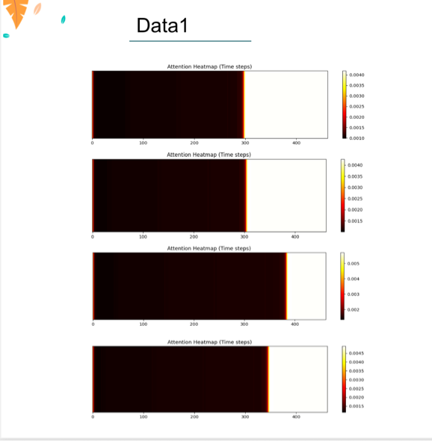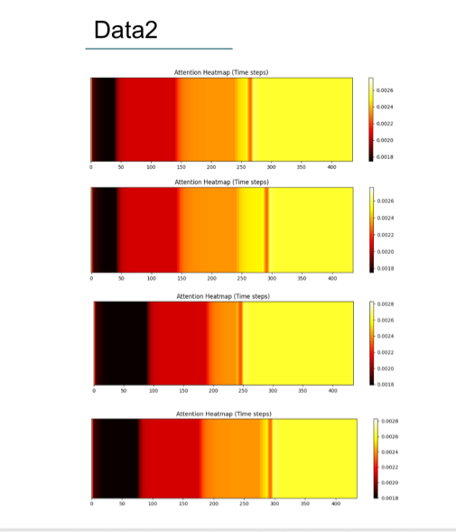

- Discussion

The results indicate that deep learning-based approaches are effective for rehabilitation motion classification. Limitations include dataset size and interpretability, which will be addressed in future work.
The experimental findings suggest that incorporating attention mechanisms significantly enhances model performance. By focusing on critical motion phases, the model aligns with expert knowledge used by rehabilitation therapists. This alignment increases trust in the model’s predictions and supports its potential clinical application.
Nevertheless, several limitations should be acknowledged. The dataset size is limited, and the diversity of rehabilitation exercises could be expanded. Future studies may integrate multimodal sensor data, such as force or electromyography signals, to further improve classification accuracy and clinical relevance.

- Conclusion

This project demonstrates the feasibility of applying LSTM-based models to rehabilitation motion analysis.The proposed approach provides a foundation for intelligent rehabilitation assessment systems.References Relevant academic literature on LSTM networks, attention mechanisms, and rehabilitation motion analysis.

